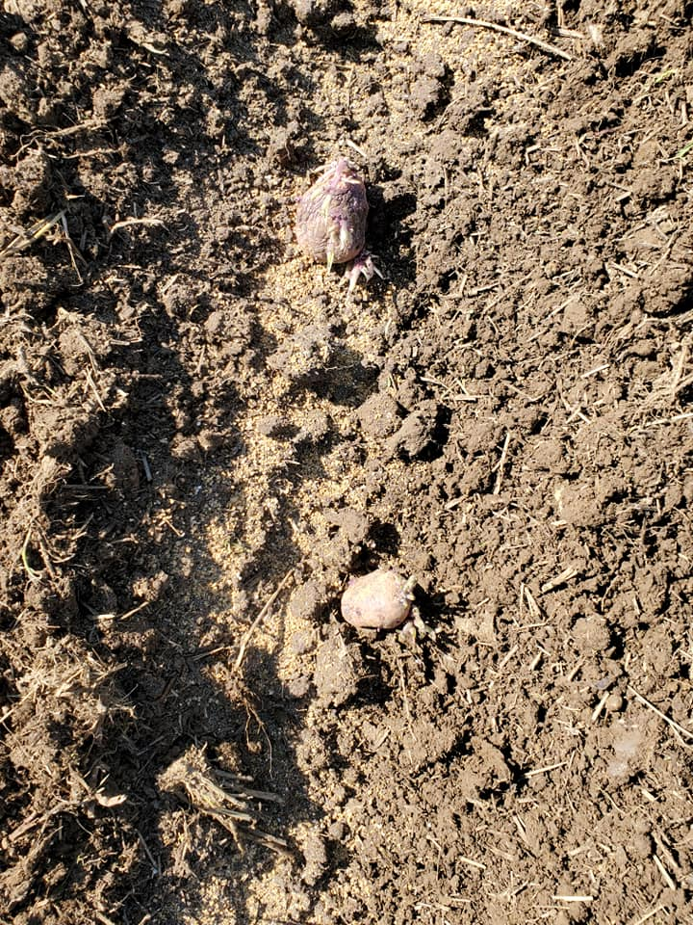

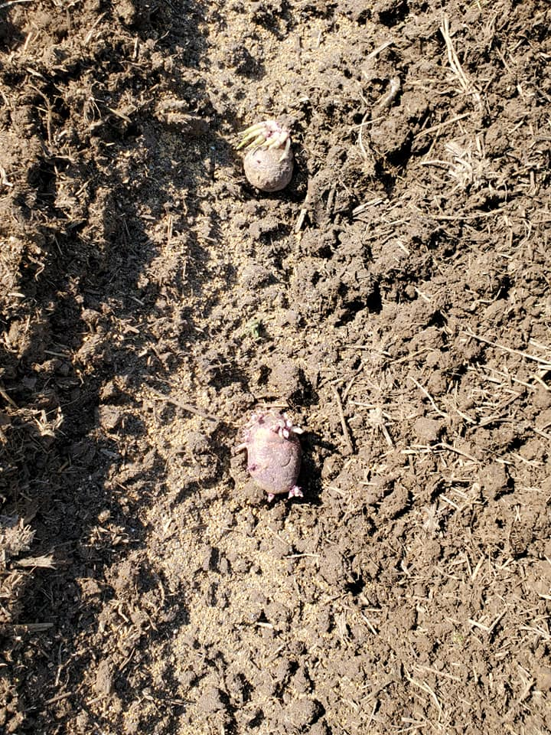

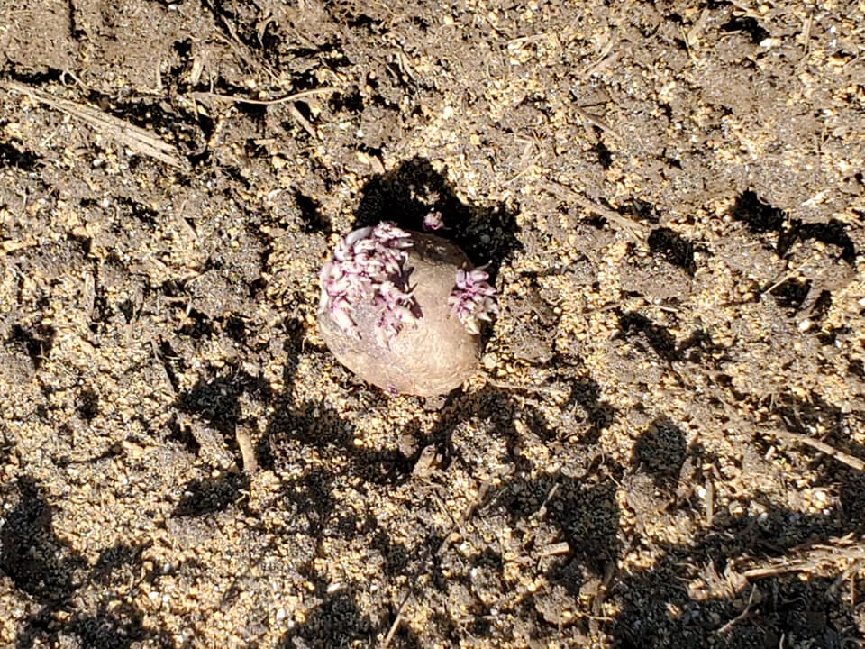

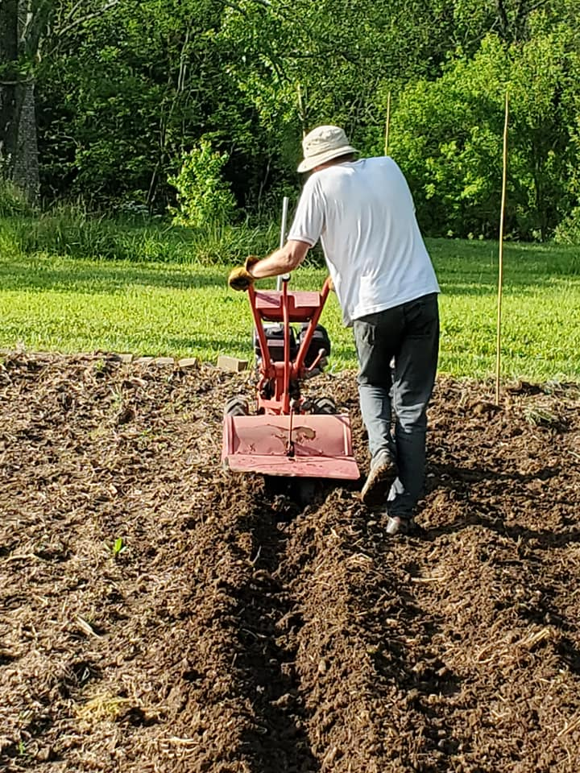

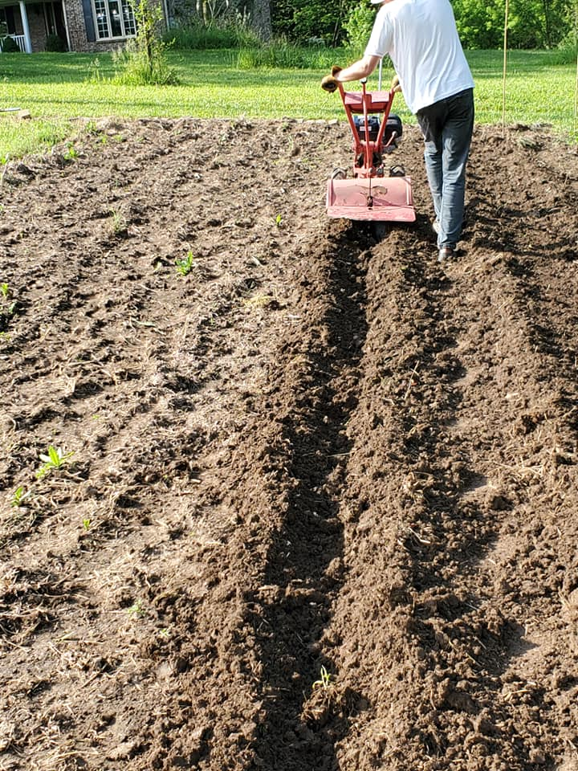

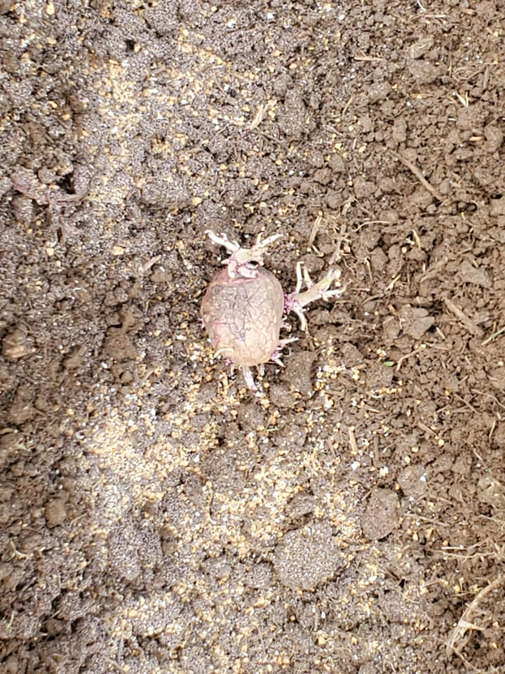

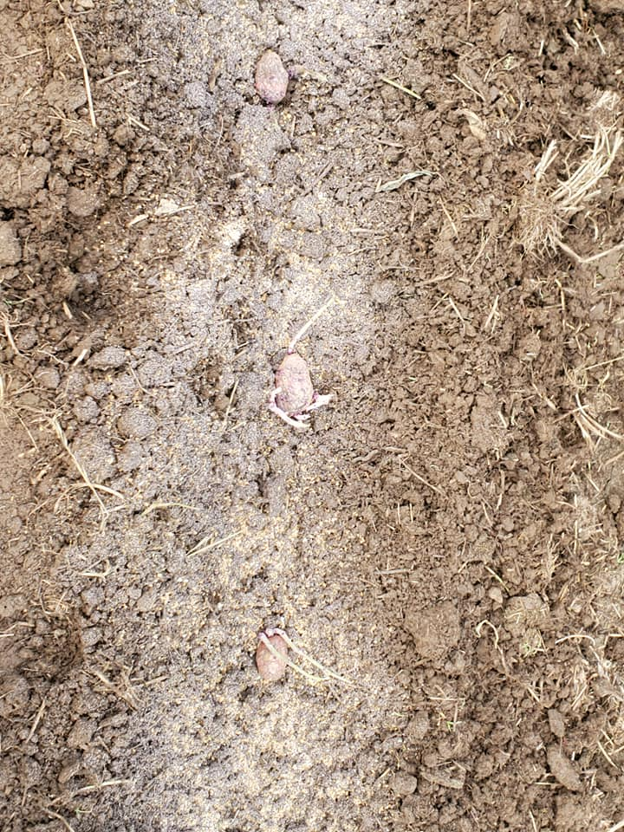

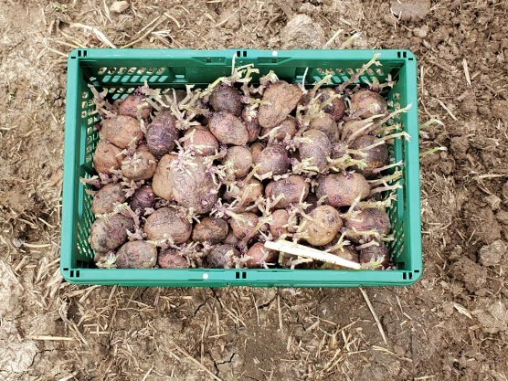

Purple Viking Potatoes Planted 05/26/2020
12” Spacing In Row
2’ Between Rows

Days to Maturity: Early Season 80 Days

Outstanding yields of spectacular deep purple potatoes with rich flavor—a winner in our taste tests!
Bright white flesh is moist and firm, adaptable for many types of cooking. Vibrant purple skins are flecked with pink for an eye-catching early market offering. Compact plants with big tubers - space closely. Good Scab resistance.
Compact habit
- For fresh market

CULTURAL INFO
Potatoes (Solanum tuberosum)are a hardy cool season crop in the the Solanaceae family which includes peppers, tomatoes, tomatillos, eggplant and ground cherries. They are classified by early, mid, and late season varieties, which refers to the days to maturity.
Soil Nutrients and Requirements
Loose, deep, well drained soil on the acidic side (pH 4.8-5.5) will grow the best potatoes. Avoid heavy nitrogen applications, as this can lead to abundant foliage but lower quality tubers that mature later. 140-150 lbs of nitrogen/acre is average.
Seeding Depth
3-6"
Plant Spacing
12"
Row Spacing
30-36"
When to Sow
Potatoes can be planted 1-2 weeks before the last frost date in spring. Small potatoes (1-1.5” diameter) can be planted whole or larger potatoes can be cut into pieces. Each piece of the tuber should have at least one eye (dormant bud). Cut the tubers a day early in order for the skin to dry before planting. Sprouts appear in 2 weeks.
Other Considerations
Hill plants shortly after emergence and again 3 weeks later, making sure to cover all exposed tubers to avoid greening, increase number of tubers, and promote larger growth.
Harvest
New potatoes can be harvested when plants begin to flower, around 7-8 weeks after planting. Storage potatoes should be harvested no earlier than 2 weeks after plants have died back.
Storage
Potatoes should be left out in a dry dark place to cure. Store potatoes in burlap, boxes, or crates in a dark, moist area at 38- 40ºF.
Pest Info
- The Colorado potato beetle (CPB) can be a significant pest. While Bacillus thuringiensis var. tenenbrionis. is effective against CPB and was formerly the easiest insecticide to use, the current formulations have been removed from OMRI-A status due to difficulties with assessing inert ingredients. Luckily there is a new addition to the arsenal in the form of spinosad (such as Entrust™). Spinosad works rapidly and effectively against CPB, as well as against corn earworm, imported cabbage worm, codling moth, and several other difficult lepidopterous pests. Ideally we will regain access to Bt so that these two formulas can be used in rotation with one another to prevent selection of resistant insects. Crop rotation, control of solanaceous weeds, barrier trenches between old and new plantings, trap cropping, use of straw mulch or row cover can delay or reduce CPB pressure.
Disease Info
- Scab, caused primarily by the bacteria Streptomyces scabies, adversely affects grade and cooking quality, though not yield and storage. Scab is most severe in dry weather, when bacteria antagonistic to Streptomyces in the potato lenticel dry up, allowing scab to more easily infect the plant. For prevention, select scab-resistant varieties and maintain good soil moisture.
- Late blight is severely destructive, with the potential of total crop loss. Caused by the fungus Phytophthora infestans, late blight is most prevalent in moister climates such as the eastern regions of the U.S. Symptoms of late blight include water-soaked areas at the leaf tips that spread inwards and become dark brown and brittle after one or two days. Symptoms can superficially resemble early blight, but are distinguished by the fact that late blight obliterates the pattern of leaf veins where as early blight does not. Action must be taken quickly if symptoms appear. Because late blight is wind borne and spreads easily, controlling its presence in your field can help nearby growers. Remove and destroy infected plants and/or use fungicidal sprays such as oxidate (such as Storox™, see Supplies) and/or copper hydroxide (such as Champion WP™). Check with your organic certifier before applying suggested compounds

